

DEPARTMENT OF COMPUTER SCIENCE AND DESIGN ACADEMIC YEAR 2024-2025 ODD SEMESTER



CD23332 LAB MANUAL SECOND YEAR
THIRD SEMESTER 2024- 2025
ODD SEMESTER

RAJALAKSHMI ENGINEERING COLLEGE
RAJALAKSHMI NAGAR, THANDALAM – 602 105



CD23331
DESIGN PROCESSES AND PERSPECTIVES LABORATORY
Laboratory Manual Note Book

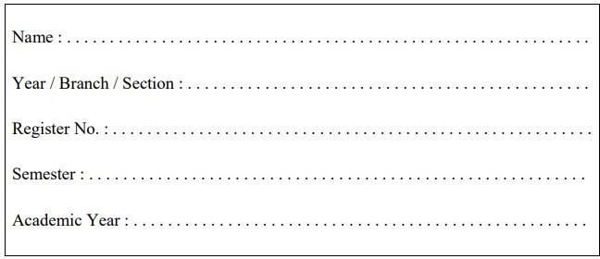

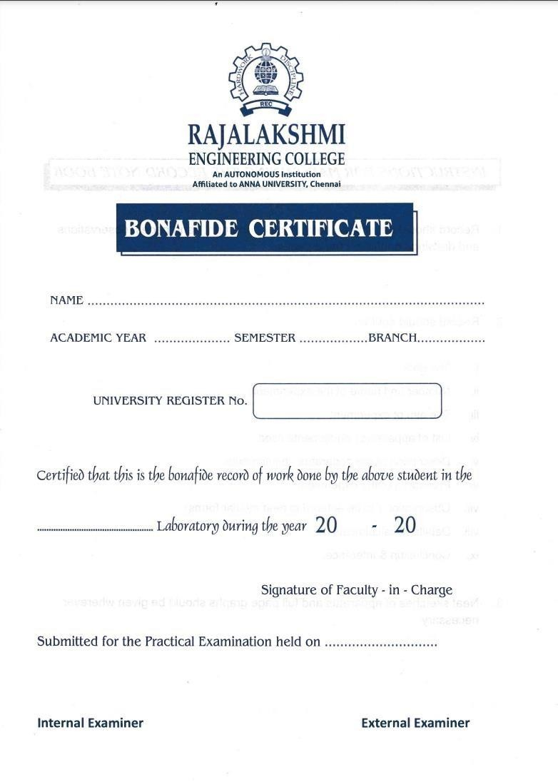

List of Experiments

1 | Design to teach mathematics to the children of 4-5 years age in school in Rural sector
2 | Design to help people to sell their handmade products in metro cities
3 | Design a social media website and chat
4 | Design a publication that support different languages
5 | Design a publication that tells comic stories
6 | Design an advertisement for mobile company
7 | Design an advertisement for any political party with images
8 | Design an advertisement for electronic products
9 | Design an advertisement for food products
10 | Design an interactive website for new institution
11 | Design a blog that publish educational post
12 | Design an interactive website for hospital management system
13 | Design an interactive website for food selling app
Requirements
Hardware |  | Intel i3 or AMD processor with 64-bit support;2 GHz or faster processor with SSE 4. or later- 8 GB RAM -Windows 10 64-it (version 1909)or later - 1.5 GB of GPU memory -4 GB of available hard-disk space
Software |  | Figma, Adobe Photoshop, HTML and CSS
Operating System |  | Windows

LAB PLAN

CD23332-DESIGN PROCESSES AND PERSPECTIVES LAB

Exercise no. | Exercise Name | Required Hours
1 | Design to teach mathematics to the children of 4-5 years age in school in Rural sector | 3
2 | Design to help people to sell their handmade products in metro cities | 6
3 | Design a social media website and chat | 3
4 | Design a publication that support different languages | 3
5 | Design a publication that tells comic stories | 3
6 | Design an advertisement for mobile company | 3
7 | Design an advertisement for any political party with images | 9
8 | Design an advertisement for electronic products | 6
9 | Design an advertisement for food products | 6
10 | Design an interactive website for new institution | 6
11 | Design a blog that publish educational post | 6
12 | Design an interactive website for hospital management system. | 3
13 | Design an interactive website for food selling app. | 3

Course Outcomes (COs)
Course Name: Design Processes and Perspectives Course Code: CD19341

Outcome 1 | Understand the various graphic design thinking process and phases
Outcome 2 | Analyze and choose between various visual components
Outcome 3 | Designing and communicating visual components
Outcome 4 | Apply design concepts for media publishing and advertising
Outcome 5 | Create website using different design concepts

CO-PO –PSO matricesofcourse
PO/PSO  CO | PO 1 | PO 2 | PO 3 | PO 4 | PO 5 | PO 6 | PO 7 | PO 8 | PO 9 | PO 10 | PO 11 | PO 12 | PSO 1 | PSO 2 | PSO 3
CD19341.1 | 3 | 1 | 3 | 2 | 3 | 2 | 3 | 2 | 1 | 1 | 1 | 3 | 1 | 3 | 1
CD19341.2 | 3 | - | 3 | - | 3 | - | - | - | - | - | 1 | 1 | 1 | 3 | 1
CD19341.3 | 3 | 3 | 3 | 2 | 3 | - | - | - | - | - | - | 1 | 1 | 3 | 2
CD19341.4 | 1 | 3 | 3 | 3 | 3 | 3 | 2 | 2 | 2 | 2 | 2 | 2 | 1 | 3 | 3
CD19341.5 | 1 | 3 | 3 | 3 | 3 | 3 | 2 | 2 | 2 | 2 | 2 | 2 | 1 | 3 | 3
Average | 2.2 | 2.0 | 3.0 | 2.0 | 3.0 | 1.6 | 1.4 | 1.0 | 1.0 | 1.0 | 1.2 | 1.8 | 1.0 | 3.0 | 2.0

Note: Enter correlation levels 1,2 or 3 as defined below:

1: Slight(Low) 2: Moderate(Medium) 3: Substantial(High) If there is no correlation, put “-“

Expt. No.:1 Date:

Design to teach mathematics to the children of 4-5 years age in school in Rural sector

Aim: To design a user interface for teaching mathematics to the children of 4-5 years age in school in the rural sector.

Tools: Figma, Photoshop

Steps:

- Create a new background layer.

- Create containers for placing images, icons and logos.

- Gradient color panel has to be used.

- Buttons and attractive fonts have been used.

- Proper navigation should be done to move from one page to another.

- Login page has to be included.

Output:

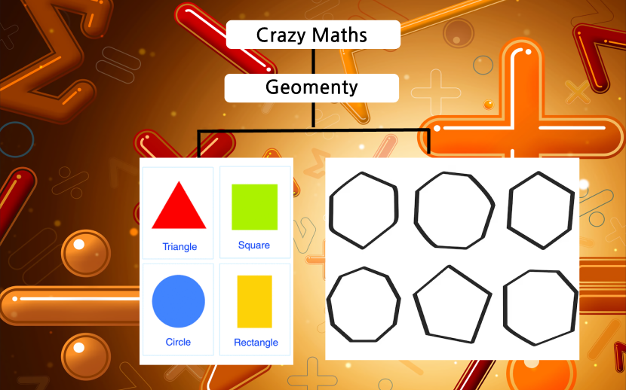

Result: Hence the design is completed and output is verified.

Expt. No.:2 Date:
Design to help people to sell their handmade products in metro cities

AIM: To Design an UI that can help people to sell their handmade products in metro cities

Tools: Figma, Photoshop

Steps:

- Create a new background layer.

- Create containers for placing images, icons and logos.

- Gradient color panel has to be used.

- Buttons and attractive fonts have been used.

- Proper navigation should be done to move from one page to another.

- Login page has to be included.

Output:

Result: Hence the design is completed and output is verified.

Expt. No.:3 Date:

Design a social media website and chat

Aim: To design a social media website and chat.

Tools: Figma, Photoshop

Steps:

- Create a new background layer.

- Create containers for placing images, icons and logos

- Gradient color panel has to be used

- Buttons and attractive fonts have been used

- Proper navigation should be done to move from one page to another

- Login page has to be included

Output:

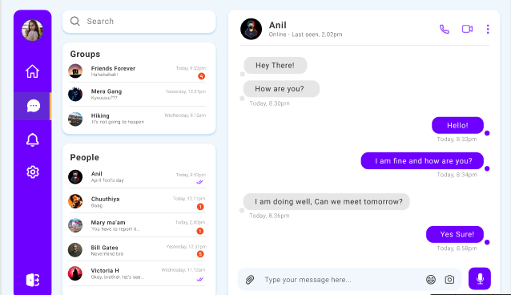

Result: Hence the design is completed and output is verified.

Expt. No.:4 Date:

Design a publication that support different languages

Aim: To design a publication that support different language

Tools: Adobe Photoshop

Steps:

- Create a new background layer.

- Create containers for placing images, icons and logos

- Gradient color panel has to be used

- Use different languages to display the content.

- Use images that support the content.

- Align white spaces between the contents.

Output:

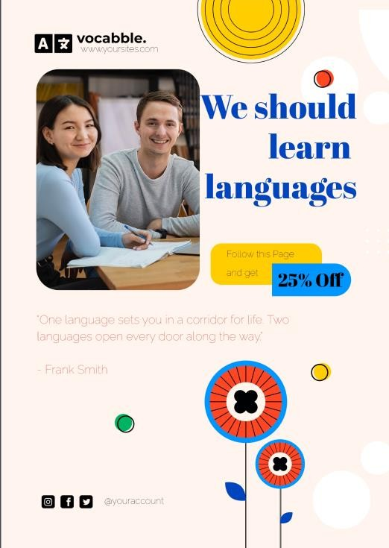

Result: Hence the design is completed and output is verified.

Expt. No.:5 Date:
Design a publication that tells comic stories

Aim: To design a Publication That Tells Comic Stories

Tools: Adobe Photoshop

Steps:

- Create a new background layer.

- Create containers for placing images, icons and logos

- Gradient color panel has to be used.

- Use different languages to display the content.

- Use images that support the content.

- Align white spaces between the contents.

Output:

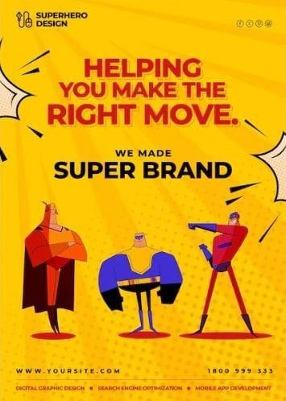

Result: Hence the design is completed and output is verified.

Expt. No.:6 Date:

Design an advertisement for mobile company

Aim: To design an advertisement for mobile company

Tools: Adobe Photoshop, Canva

Steps:

- Create a new background layer.

- Create containers for placing images, icons and logos

- Gradient color panel has to be used

- Images that support the context must be placed.

- Written context must be emphasized.

- Appropriate color palette must be used.

Output:

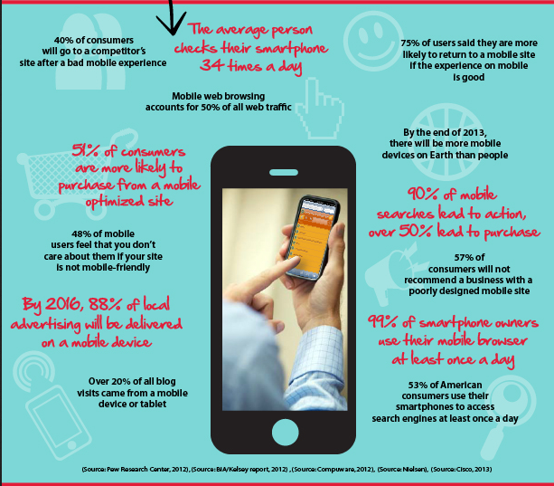

Result: Hence the design is completed and output is verified.

Expt. No.:7 Date:

Design an advertisement for any political party with images

Aim: To design an advertisement for any political party with images

Tools: Adobe Photoshop, Canva.

Steps:

- Create a new background layer.

- Create containers for placing images, icons and logos.

- Gradient color panel has to be used.

- Images that support the context must be placed.

- Written context must be emphasized.

- Appropriate color palette must be used.

Output:



Result: Hence the design is completed and output is verified.

Expt. No.:8

Date:

Design an advertisement for electronic products

Aim: To design an advertisement for electronic products

Tools: Adobe Photoshop, Canva

Steps:

- Create a new background layer.

- Create containers for placing images, icons and logos.

- Gradient color panel has to be used .

- Images that support the context must be placed.

- Written context must be emphasized.

- Appropriate color palette must be used.

Output:



Result: Hence the design is completed and output is verified.

Expt. No.:9 Date:

Design an advertisement for food products

Aim: To design an advertisement for food products

Tools: Adobe Photoshop, Canva

Steps:

- Create a new background layer.

- Create containers for placing images, icons and logos.

- Gradient color panel has to be used .

- Images that support the context must be placed.

- Written context must be emphasized.

- Appropriate color palette must be used.

Output:

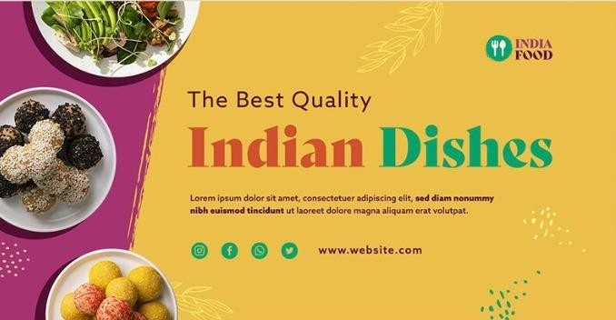
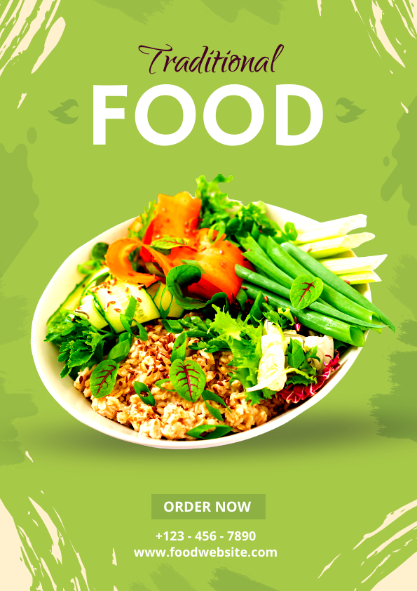

Result: Hence the design is completed and output is verified.

Expt. No.:10 Date:

Design an interactive website for new institution

Aim: To design interactive website for new institution

Tools: HTML, CSS

Steps:

  - Create a document of type HTML.

  - Craft a style sheet for better design.

  - Include the link of the stylesheet to the HTML file.

  - Assign a title for each page.

  - Add the required styles and attributes for the HTML tags.

  - Include action tag to navigate from one page to another.

Output:

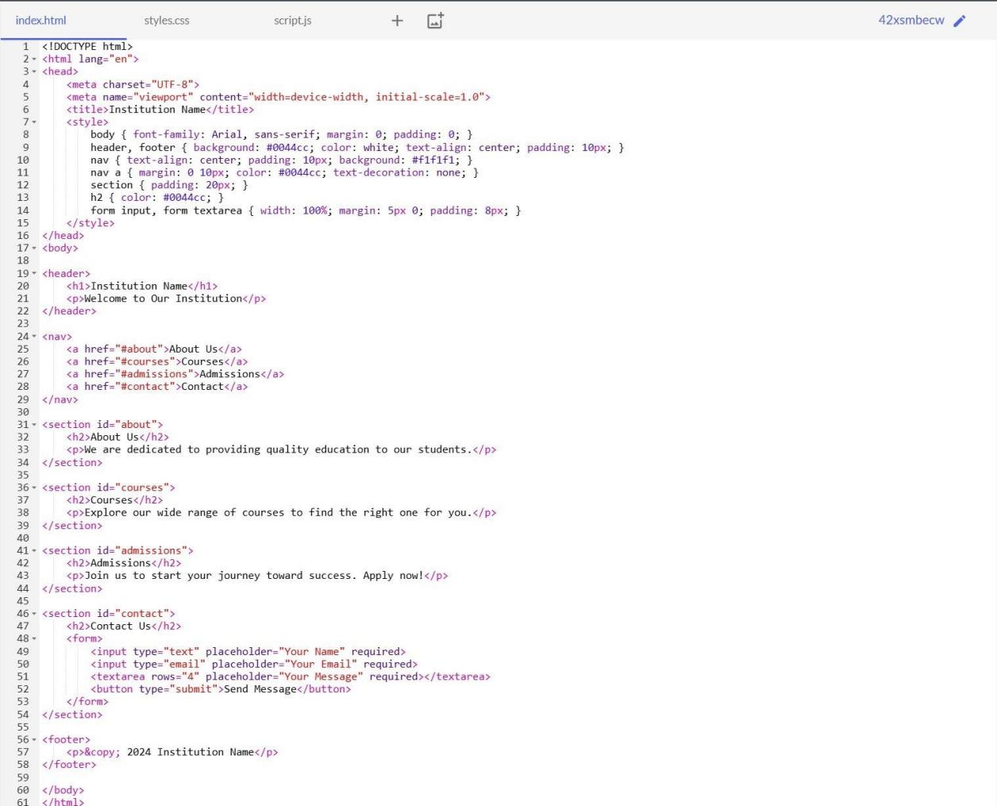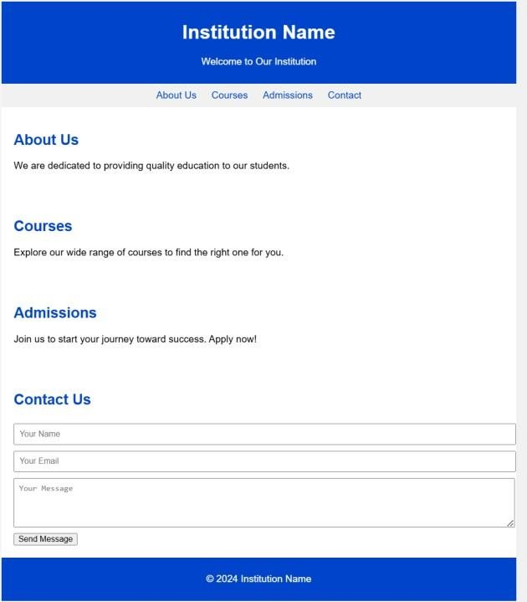

Result: Hence the design is completed and output is verified.

Expt. No.:11 Date:

Design A Blog That Publish Educational Post

Aim: To design a blog that publishes educational post

Tools: HTML, CSS

Steps:

- Create a document of type HTML.

- Craft a style sheet for better design.

- Include the link of the stylesheet to the HTML file.

- Assign a title for each page.

- Add the required styles and attributes for the HTML tags.

- Include action tag to navigate from one page to another.

Output:

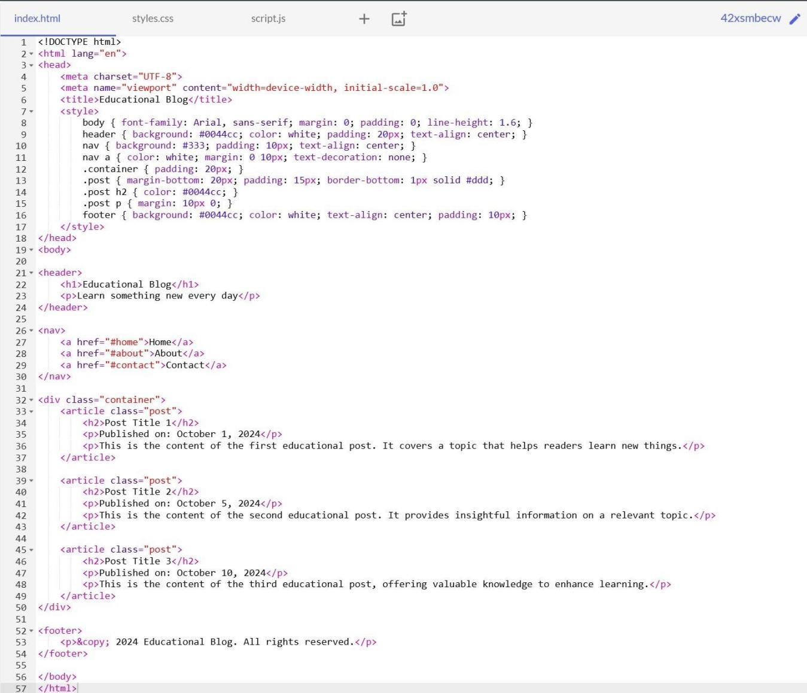

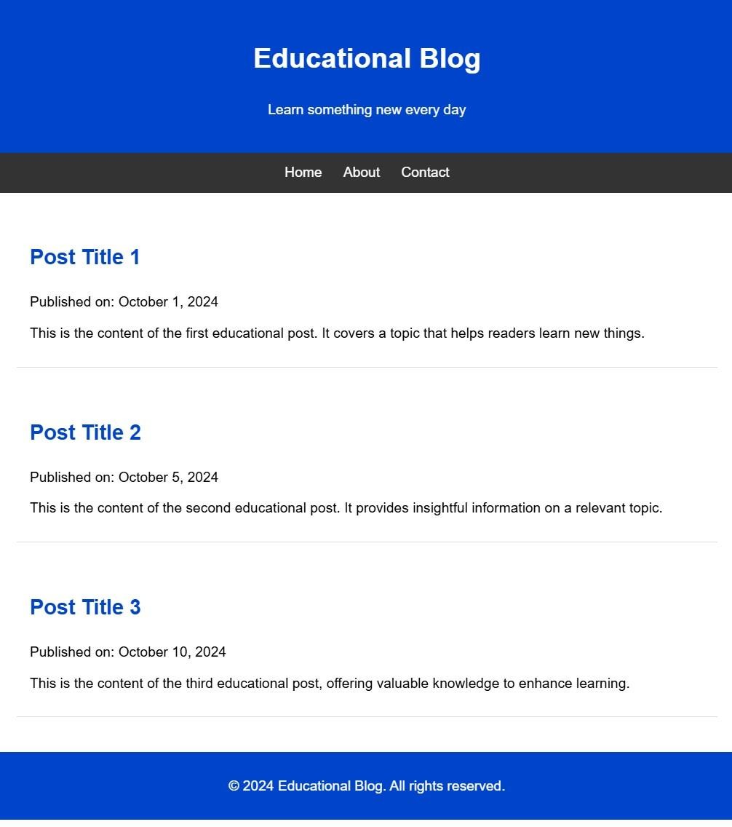

Result: Hence the design is completed and output is verified.

Expt. No.:12 Date:

Design An Interactive Website For Hospital Management
System

Aim: To design interactive website for hospital management system

Tools: HTML, CSS

Steps:

- Create a document of type HTML.

- Craft a style sheet for better design.

- Include the link of the stylesheet to the HTML file.

- Assign a title for each page.

- Add the required styles and attributes for the HTML tags.

- Include action tag to navigate from one page to another.

Output:
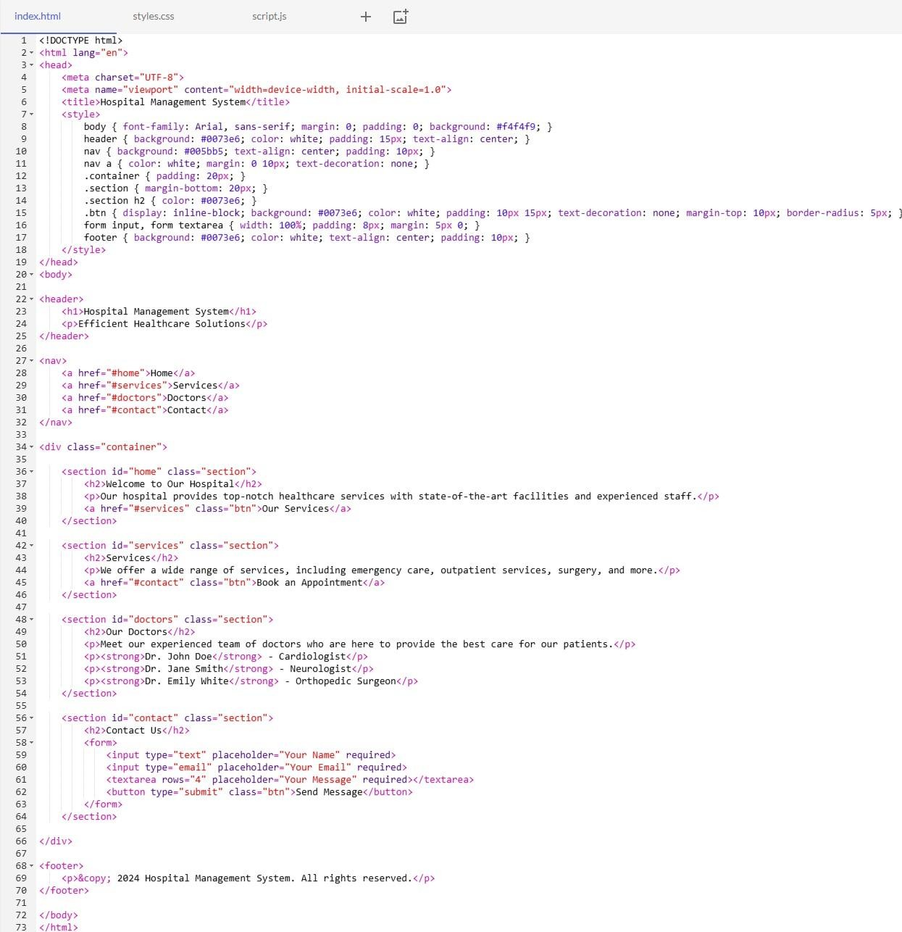

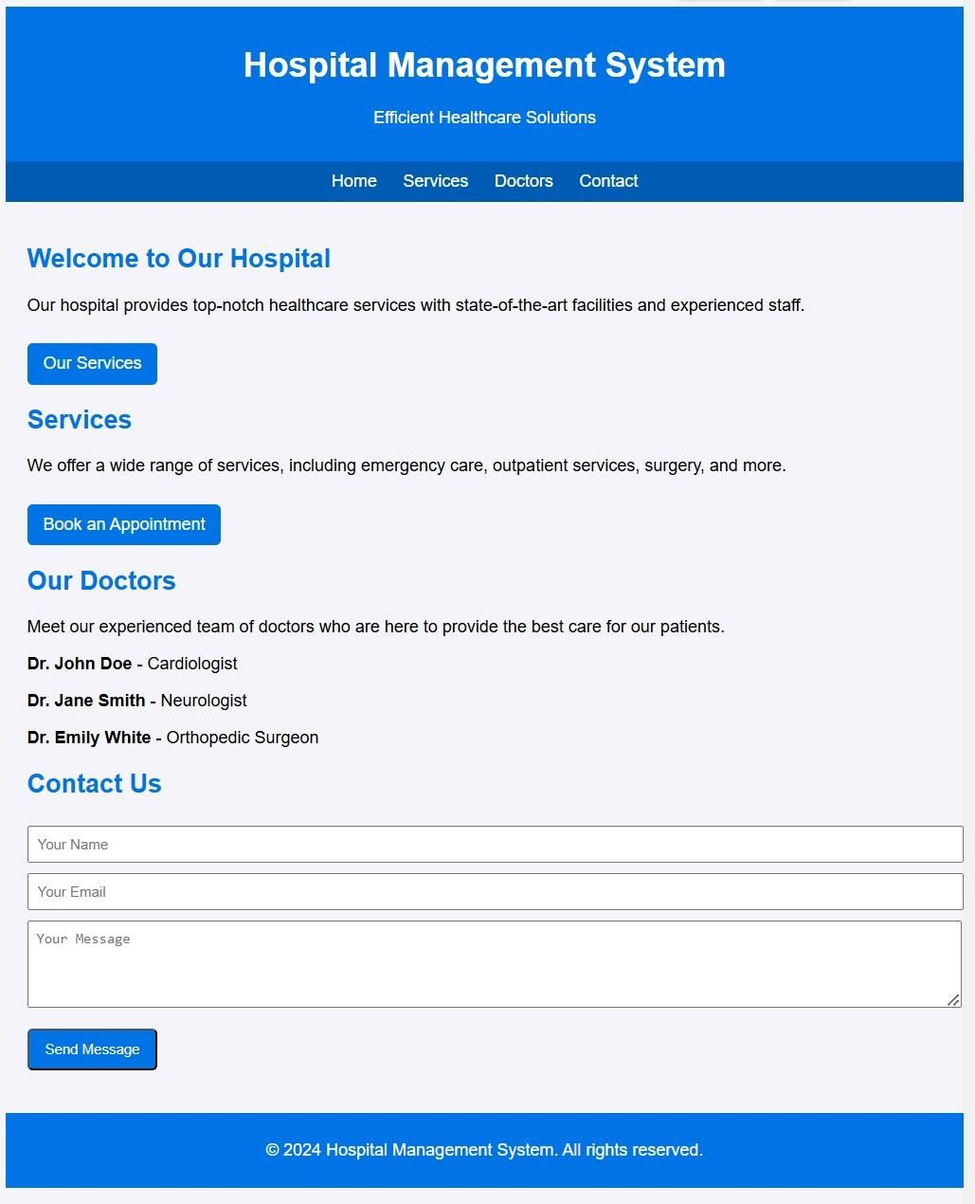

Result: Hence the design is completed and output is verified.

Expt. No.:13 Date:

Design An Interactive Website For Food Selling App

Aim: To design a interactive website for food selling app

Tools: HTML, CSS

Steps:

- Create a document of type HTML.

- Craft a style sheet for better design.

- Include the link of the stylesheet to the HTML file.

- Assign a title for each page.

- Add the required styles and attributes for the HTML tags.

- Include action tag to navigate from one page to another.

Output:
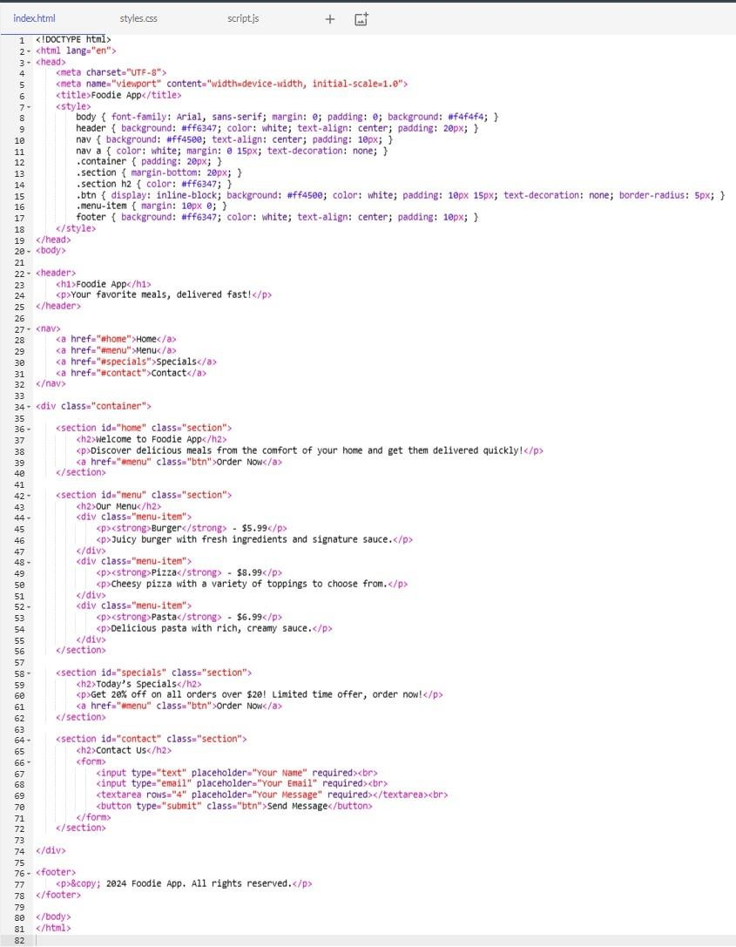

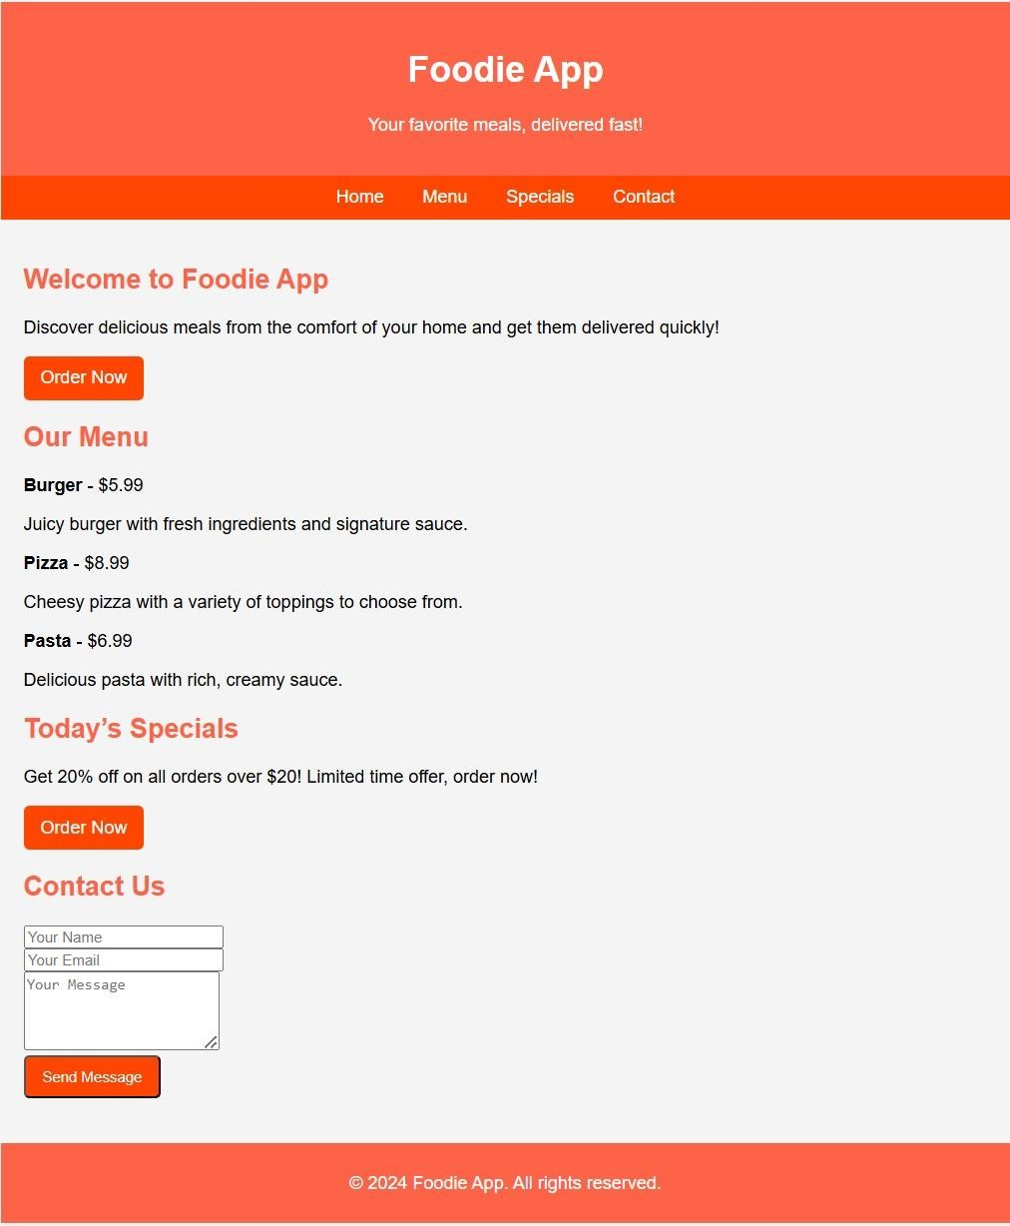

Result: Hence the design is completed and output is verified.

